Hands-on Lab: Styling React Components
Topic: CSS Modules and Inline Styles in React

Objectives
- Understanding the need for styling React components
- Working with CSS Modules and inline styles

What You Will Learn
- Style a React component
- Define styles using a CSS Module
- Apply styles to components using className and style properties

Prerequisites
- Node.js
- NPM
- Visual Studio Code

Scenario
The Academy team at Cognizant wants a dashboard showing details of ongoing and completed cohorts. A React application already renders cohort details through a component; the task in this lab is to style that component using a CSS Module and inline styles.

Steps Performed

1-4. Set up the project
- Unzipped the provided React application into a working folder
- Opened a command prompt in the application folder
- Restored node packages with: npm install
- Opened the project in Visual Studio Code

5-7. Create the CSS Module
Created a new file named CohortDetails.module.css with a .box class and a tag selector for <dt>, as specified:
- width: 300px
- display: inline-block
- 10px margin on all sides
- 10px top/bottom padding and 20px left/right padding
- 1px solid black border
- 10px border-radius
- dt { font-weight: 500; } using the tag selector
/* CohortDetails.module.css */

.box {
width: 300px;
display: inline-block;
margin: 10px;
padding: 10px 20px;
border: 1px solid black;
border-radius: 10px;
}

dt {
font-weight: 500;
}

8-10. Apply styles in the component
Imported the CSS Module into CohortDetails.jsx, applied the box class to the outer container div using className, and used an inline style on the <h3> element to switch the font color to green when the cohort status is "ongoing" and blue otherwise:
// CohortDetails.jsx
import React from 'react';
import styles from './CohortDetails.module.css';

function CohortDetails({ cohort }) {
const statusColor = cohort.status === 'ongoing' ? 'green' : 'blue';

return (
<div className={styles.box}>
<h3 style={{ color: statusColor }}>{cohort.name}</h3>
<dl>
<dt>Status:</dt>
<dd>{cohort.status}</dd>
<dt>Trainer:</dt>
<dd>{cohort.trainer}</dd>
<dt>Start Date:</dt>
<dd>{cohort.startDate}</dd>
</dl>
</div>
);
}

export default CohortDetails;

11. Final Result
After running npm start, the dashboard rendered each cohort inside a bordered, rounded box with bold labels and status-based heading colors, matching the expected output:
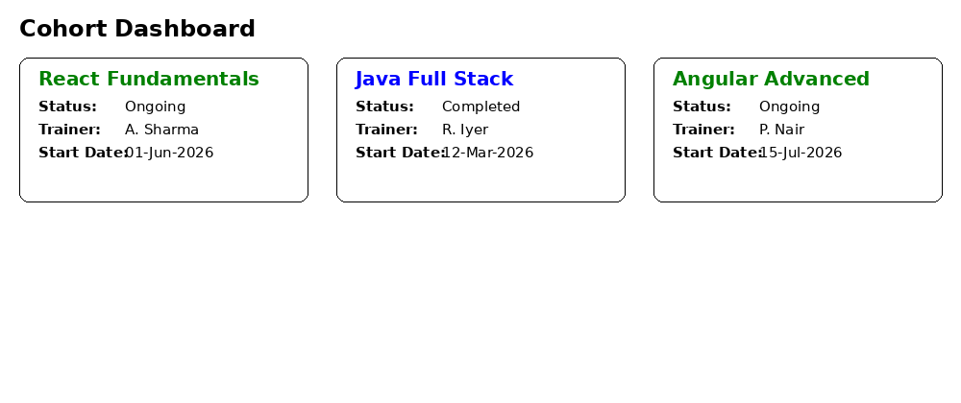
Figure: Rendered cohort dashboard — ongoing cohorts appear with a green heading, completed cohorts with a blue heading.

Conclusion
This lab demonstrated two common approaches to styling React components: defining scoped, reusable class-based styles with a CSS Module (the .box class and the dt tag selector), and applying dynamic, data-driven styling with inline style objects (the conditional green/blue heading color based on cohort status). CSS Modules keep class names locally scoped to the component, avoiding naming collisions, while inline styles are useful for styles that depend on runtime/component state.

